CODE (not for authors )

TRANSIENT TRANSMISSION OF THz METAMATERIALS ANTENNAS EXCITED BY PS LASER PULSES

E. Janssens¹, M. Bejide¹, V. D. Lam^{2,3}, and N. T. Tung^{2,3}

¹KU Leuven, Quantum Solid-State Physics, Department of Physics and Astronomy, Leuven, Belgium
²Institute of Materials Science, Vietnam Academy of Science and Technology, Hanoi, Vietnam
³Graduate University of Science and Technology, Hanoi, Vietnam
Email: ewald.janssens@kuleuven.be
ABSTRACT
The picosecond dynamics of excited charge carriers in the silicon substrate of THz metamaterial antennas was studied by time-resolved THz pump-THz probe spectroscopy using light from a tunable free electron laser in the 9.3–16.7 THz frequency range and fluences of 2–12 J/m2. Depending on the excitation wavelength with respect to the resonance center, transient transmission increase, decrease, or a combination of both was observed. The dependence of the transient response on the dopant type and concentration of the silicon substrate, the substrate temperature, and the coupling between neighboring antennas, was explored. Electromagnetic simulations in combination with an analytical impact ionization model provide an interpretation for the experimental results. The transient transmission changes can be explained by local electric field enhancement, which induces impact ionization in the silicon substrate, increasing the local number of charge carriers by several orders of magnitude, and their subsequent diffusion and recombination dynamics (Fig. 1). The studied metamaterials can be integrated with common semiconductor devices and can potentially be used in sensing applications and THz energy harvesting.
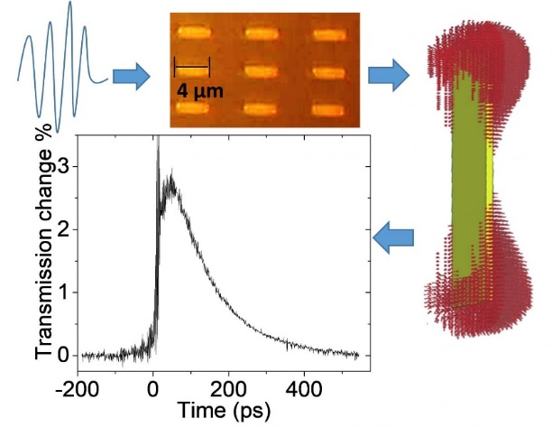
Figure 1. Transient transmission of metamaterial antennas after THz excitations can be explained by local electric field enhancement, which induces impact ionization in the silicon substrate.
Acknowledgement: This work is supported by Fonds Wetenschappelijk Onderzoek (FWO) under the grant number G0E62.18N and Vietnam National Foundation for Science and Technology Development (NAFOSTED) under the grant number FWO.103.2017.01.
[1] M. Bejide et al., Optics Express 2021, 29, 170-181.

